SHOWS / MEETINGS / EVENTS

QUOTE OF THE MONTH

“The wisdom of the wise and the experience of the ages are perpetuated in quotations”. – Benjamin Disraeli

LOCAL EVENTS
Page 1
DO MURALISTS NEED A CONTRACTOR'S LICENCE?
Page 5
CLASSES / WORKSHOPS
Page 6
WANT ADS
Page 8
LINKING AROUND
Page 9
GROUP WEB SITES
Page 10
THE GOOD NEWS
Page 11
L. MARIE HORTON
Page 12
MARY MAUGHELLI
Page 13
SPECTRUM ART GALLERY
Page 14
WHAT MAKES A BOOK ATHRILLER?
Page 16
SUBSCRIBE
Page 18

Events Submitted to the Calendar must have the organization name, date & time, Contact information, and pricing.
Don’t Forget To Send in Your Profile for Featured Artist /Writer or Organization / Multi-Artist Gallery BY THE 20TH OF THE MONTH

JULY

July 1/8 FNA (FRIENDS ‘N ART) NEW LOCATION FOR MEETINGS! meetings where artists get and paint at Friends Community church, 5688 N 1st, Fresno, CA 93710 9:00 a.m. to Noon. 1st & 3rd Saturdays For more information contact Mary Newton 559.906-3907
4/11/18/25 PAA (PLACERVILLE ART ASSN) invites you to participate in our Tuesday Mornings Paint Together. Meet with other artists to paint and share ideas. We learn from each other. Everyone welcome. Every Tuesday morning 9:30-12:00 AM Placerville Senior Center craftsroom 937 Spring St, Placerville For more information: call 530-913-1555 (Homer Rail)
July 5 YWA (YOSEMITE WESTERN ARTISTS) FUN WITH PHOTOSHOP GROUP now meets 1st Wednesday of the month at 6 pm at Timberline Gallery, 40982 Hwy 41, Suite 6, Oakhurst, CA. Open to YWA members and visitors, no charge. For further information, call Zyg Zee at 559- 683-0762 or Norma Rogers at 559-642-7485.
July 6 1ST THURSDAY ARTHOP covers the downtown area and the Tower District. The ArtHop program is sponsored by the Fresno Arts Council. It is a monthly event featuring art exhibits in over 60 venues in Fresno County. Art venues include galleries/artist studios, retail outlets and public spaces. To plan your ArtHop experience, log in to www.fresnoarthop.org to check for a list of locations, event/exhibit details, days and times, and/or the specific venue that interests you.
July 6 PHOTO COLLECTIVE GENERAL MEETING. Meetings are normally held on the first Thursday of the month. Time: 7 p.m. Location: Stonebridge Apartments Club House 2800 Braden Ave, Modesto, CA 95356 Meet in the clubhouse just to the left of the pool as you make your way from the guest parking area. For more information, go to www.photocollective.org
7/14/21/28 YWA (YOSEMITE WESTERN ARTISTS) LIVE MODEL PAINTING: Fridays from 9:30 am - 12:30 pm. All are welcome to paint/draw/photograph/sculpt from hired models at Gertrude Schoolhouse, Road 600, Ahwahnee, CA. Cost is $7.00 for YWA members and $10.00 for non-members. Check Facebook page (www.facebook.com/YosemiteWesternArtists) for related announcements and updates. Contact: Doug Boomer at 559-642-3648 or dboomer@sti.net.
July 8 YWA (Yosemite Western Artists) General meeting and art demonstration (second Saturday of each month) at Gertrude Schoolhouse, Road 600, Ahwahnee. 11:15 am, General Meeting; 11:45 am, Potluck; 12:15 pm, Artist demonstration — Myrna Axt, Mixed Media Sculpture. Cost for members is $5.00; non-members $7.00. For information go to https://www.facebook.com/YosemiteWesternArtists or subscribe to our newsletter at yosemitewesternartists.com or call Sandee Scott at 559-760-1058.
July 8 THE BAKERSFIELD ART ASSOCIATION 1607 19th Street, Bakersfield, CA 93301 (661-869- 2320) will be having a meeting open to the public on Saturday, 9 am to noon, program at 10 am. (2nd Saturday of each month). Cheri Sperl will speak about small portraits in oils
July 8 ARTIST CALL: ARTISIAN FAIRE: Vintage - Upcycle - Hand-crafted A place for local artisans to sell their wares, and for the community to come out and support them while enjoying beverages and food from our cafe'! We will now be hosting our Artisan Faire on the second Saturday of each month, with outdoor and indoor vendor spots available, weather permitting. For more information and to obtain an application, please contact us at miacuppa620@gmail.com. Mia Cuppa Caffe' 620 E Olive Ave, Fresno, California 93728
July 9 PAA (PLACERVILLE ART ASSN) Our general meetings are the 2nd Sundays of the month at 1:30pm at the Senior Center in Placerville. 937 Spring St, Placerville, CA 95667. For more information contact kspoole@hughes.net
July 10 ART CENTER MORRO BAY GENERAL MEETING AND ART DEMONSTRATION at, 835 Main Street, Morrow Bay, CA 93442, 3:00 p.m. on the 2nd Monday of every month No charge for attending. For more information contact: artcentermorrobay.com phone: (805) 722-2504.
July 11 ADAS (Alamo Danville Artists’ Society) meets on the second Tuesday of each month (7:30pm) at Alamo Women’s Club (1401 Danville Blvd. Alamo, CA 94507). Meetings feature a lively exchange of creative ideas and demonstrations/lectures by distinguished local and nationally renowned guest artists. For more information: http://adas4art.org/ Or contact: membership@adas4art.org
July 12 CAG (CLOVIS ART GUILD) General Meeting and Art Demonstration. 7—9PM Clovis Veterans Memorial Building, 808 4th st, Clovis, CA 93612. Art demonstration is Free to members, Suggested donation from Guests $5.00. For more information, contact President Gail Daley 559-960-2428 or Membership Chair Alice Sutton 787-2386 or go to www.clovisartguild.com Watercolor pouring by Bonnie Doyle.
July 13 YWA (YOSEMITE WESTERN ARTISTS) PHOTO GROUP Meets every Second Thursday of the Month, 7-9 pm at the Stellar Gallery 40982 Hwy 41, Suite 1, Oakhurst, CA 93644 Free to Members and $10 for guests (1st time free) Each meeting has a theme. Meeting topic details, out our Facebook page:
https://www.facebook.com/YosemiteWesternArtists
July 18 KINGS COUNTY ART LEAGUE meets the 3rd Tuesday of each month, 6:30 PM in the Kings Art Center, 605 N Douty, Hanford, CA 93230. Meetings include educational art demonstrations. For more information contact the office at 559-584-1605 or e-mail them at info@kingsartcenter.org Website & Facebook page
http://www.kingsartcenter.org https://www.facebook.com/KingsArtCenterHanford
July 20 3RD THURSDAY ART HOP covers Metropolitan Fresno and Clovis The ArtHopTM program is a monthly event featuring art exhibits in over 50 art venues in Fresno County. Art venues include galleries, work studios, retail outlets, and public spaces that art patrons can visit on the first and third Thursday of each month and other designated days. Please support our Metro venues; come by and meet local artists and enjoy their artwork, receptions, beverages, and music on the 3rd Thursday of each month, from 5pm to 8 pm. To plan your ArtHop experience, log in to www.fresnoarthop.org to make your list
July 22 ARTIST CALL: Receiving for the CAG Miniature Works Art Show 10:AM—Noon, at the Fresno Art Hub, 2024 N Van Ness, Fresno CA 93704 For more information, contact Show Chair Gail Daley 559-960-2428 or Alice Sutton 559-787-2386 Artist reception and award ceremony August 3rd, 1st Thursday Art Hop, 5-8 PM at the Show location. Show will hang through August 26, 2017.Prospectus available at www.clovisartguild.com and on Clovis Art Guild Facebook Fan Page
July 22 THE PLACERVILLE ARTS ASSOCIATION'S monthly general meetings are held on the 3rd Sunday of each month from 1:30 to approximately 3:30 at the Placerville Senior Center, 937 Spring St, Placerville, CA 95667. http://www.placervillearts.com Karen Poole President kspoole@hughes.net or (530) 672-0943.
July 26 YWA (YOSEMITE WESTERN ARTISTS) PLEIN AIR OUTING. Outings are usually the 4th Wednesday of each month. Locations vary. Interested parties meet in the CVS parking lot in Oakhurst at 9:00 am where car-pooling arrangements are made to the eventual destination. Cost for members is $3.00; non-members $5.00. To stay informed of Plein Air destinations, follow YWA on Facebook — https://www.facebook.com/YosemiteWesternArtists. Plein Air Coordinator: Terry Robinson, terryrobinson@sti.net.

AUGUST

1/8/15/22/29 PAA (PLACERVILLE ART ASSN) invites you to participate in our Tuesday Mornings Paint Together. Meet with other artists to paint and share ideas. We learn from each other. Everyone welcome. Every Tuesday morning 9:30-12:00 AM Placerville Senior Center craftsroom 937 Spring St, Placerville For more information: call 530-913-1555 (Homer Rail)
Aug 2 YWA (YOSEMITE WESTERN ARTISTS) FUN WITH PHOTOSHOP GROUP now meets 1st Wednesday of the month at 6 pm at Timberline Gallery, 40982 Hwy 41, Suite 6, Oakhurst, CA. Open to YWA members and visitors, no charge. For further information, call Zyg Zee at 559- 683-0762 or Norma Rogers at 559-642-7485.
Aug 3 1ST THURSDAY ARTHOP covers the downtown area and the Tower District. The ArtHop program is sponsored by the Fresno Arts Council. It is a monthly event featuring art exhibits in over 60 venues in Fresno County. Art venues include galleries/artist studios, retail outlets and public spaces. To plan your ArtHop experience, log in to www.fresnoarthop.org to check for a list of locations, event/exhibit details, days and times, and/or the specific venue that interests you.
Aug 3 PHOTO COLLECTIVE GENERAL MEETING. Meetings are normally held on the first Thursday of the month. Time: 7 p.m. Location: Stonebridge Apartments Club House 2800 Braden Ave, Modesto, CA 95356 Meet in the clubhouse just to the left of the pool as you make your way from the guest parking area. For more information, go to www.photocollective.org
4/11/18/25 YWA (YOSEMITE WESTERN ARTISTS) LIVE MODEL PAINTING: Fridays from 9:30 am - 12:30 pm. All are welcome to paint/draw/photograph/sculpt from hired models at Gertrude Schoolhouse, Road 600, Ahwahnee, CA. Cost is $7.00 for YWA members and $10.00 for non-members. Check Facebook page (www.facebook.com/YosemiteWesternArtists) for related announcements and updates. Contact: Doug Boomer at 559-642-3648 or dboomer@sti.net.
Aug 5/12 FNA (FRIENDS ‘N ART) NEW LOCATION FOR MEETINGS! meetings where artists get and paint at Friends Community church, 5688 N 1st, Fresno, CA 93710 9:00 a.m. to Noon. 1st & 3rd Saturdays For more information contact Mary Newton 559.906-3907
Aug 8 ADAS (Alamo Danville Artists’ Society) meets on the second Tuesday of each month (7:30pm) at Alamo Women’s Club (1401 Danville Blvd. Alamo, CA 94507). Meetings feature a lively exchange of creative ideas and demonstrations/lectures by distinguished local and nationally renowned guest artists. For more information: http://adas4art.org/ Or contact: membership@adas4art.org
Aug 8 YWA (YOSEMITE WESTERN ARTISTS) PHOTO GROUP Meets every Second Thursday of the Month, 7-9 pm at the Stellar Gallery 40982 Hwy 41, Suite 1, Oakhurst, CA 93644 Free to Members and $10 for guests (1st time free) Each meeting has a theme. Meeting topic details, out our Facebook page:
https://www.facebook.com/YosemiteWesternArtists
Aug 9 CAG (CLOVIS ART GUILD) General Meeting and Art Demonstration. 7—9PM Clovis Veterans Memorial Building, 808 4th st, Clovis, CA 93612. Art demonstration is Free to members, Suggested donation from Guests $5.00. For more information, contact President Gail Daley 559-960-2428 or Membership Chair Alice Sutton 787-2386 or go to www.clovisartguild.com Critique by Dennis Lewis – bring a painting!.
Aug 12 YWA (Yosemite Western Artists) General meeting and art demonstration (second Saturday of each month) at Gertrude Schoolhouse, Road 600, Ahwahnee. 11:15 am, General Meeting; 11:45 am, Potluck; 12:15 pm, Artist demonstration — Myrna Axt, Mixed Media Sculpture. Cost for members is $5.00; non-members $7.00. For information go to https://www.facebook.com/YosemiteWesternArtists or subscribe to our newsletter at yosemitewesternartists.com or call Sandee Scott at 559-760-1058.
Aug 12 THE BAKERSFIELD ART ASSOCIATION 1607 19th Street, Bakersfield, CA 93301 (661-869- 2320) will be having a meeting open to the public on Saturday, 9 am to noon, program at 10 am. (2nd Saturday of each month). Cheri Sperl will speak about small portraits in oils
Aug 12 ARTIST CALL: ARTISIAN FAIRE: Vintage - Upcycle - Hand-crafted A place for local artisans to sell their wares, and for the community to come out and support them while enjoying beverages and food from our cafe'! We will now be hosting our Artisan Faire on the second Saturday of each month, with outdoor and indoor vendor spots available, weather permitting. For more information and to obtain an application, please contact us at miacuppa620@gmail.com. Mia Cuppa Caffe' 620 E Olive Ave, Fresno, California 93728
Aug 13 PAA (PLACERVILLE ART ASSN) Our general meetings are the 2nd Sundays of the month at 1:30pm at the Senior Center in Placerville. 937 Spring St, Placerville, CA 95667. For more information contact kspoole@hughes.net
Aug 14 ART CENTER MORRO BAY GENERAL MEETING AND ART DEMONSTRATION at, 835 Main Street, Morrow Bay, CA 93442, 3:00 p.m. on the 2nd Monday of every month No charge for attending. For more information contact: artcentermorrobay.com phone: (805) 722-2504.
Aug 15 KINGS COUNTY ART LEAGUE meets the 3rd Tuesday of each month, 6:30 PM in the Kings Art Center, 605 N Douty, Hanford, CA 93230. Meetings include educational art demonstrations. For more information contact the office at 559-584-1605 or e-mail them at info@kingsartcenter.org Website & Facebook page
http://www.kingsartcenter.org https://www.facebook.com/KingsArtCenterHanford

Aug 17 3RD THURSDAY ART HOP covers Metropolitan Fresno and Clovis The ArtHopTM program is a monthly event featuring art exhibits in over 50 art venues in Fresno County. Art venues include galleries, work studios, retail outlets, and public spaces that art patrons can visit on the first and third Thursday of each month and other designated days. Please support our Metro venues; come by and meet local artists and enjoy their artwork, receptions, beverages, and music on the 3rd Thursday of each month, from 5pm to 8 pm. To plan your ArtHop experience, log in to www.fresnoarthop.org to make your list
Aug 19 THE PLACERVILLE ARTS ASSOCIATION'S monthly general meetings are held on the 3rd Sunday of each month from 1:30 to approximately 3:30 at the Placerville Senior Center, 937 Spring St, Placerville, CA 95667. http://www.placervillearts.com Karen Poole President kspoole@hughes.net or (530) 672-0943.
Aug 23 YWA (YOSEMITE WESTERN ARTISTS) PLEIN AIR OUTING. Outings are usually the 4th Wednesday of each month. Locations vary. Interested parties meet in the CVS parking lot in Oakhurst at 9:00 am where car-pooling arrangements are made to the eventual destination. Cost for members is $3.00; non-members $5.00. To stay informed of Plein Air destinations, follow YWA on Facebook — https://www.facebook.com/YosemiteWesternArtists. Plein Air Coordinator: Terry Robinson, terryrobinson@sti.net.

DO MURALISTS NEED CONTRACTOR’S LICENSE?

By the Practical Artist
http://www.thepracticalartist.com/the-practical-artists-blog.php

Most states regulate construction contractors. In California, the Contractors State License Board (CSLB) was created to protect consumers by licensing and regulating California's construction industry. Visual Artists and visual art does not usually come under construction laws, however there is one facet of the visual art world that does: Murals. Wikipedia defines murals as any piece of artwork painted or applied directly on a wall ceiling or other large permanent surface. For instance, if you are invited to paint a mural on the wall of your doctor’s office and you were paid more than $500, under California construction laws, you might need a Contractor’s License. Artists may not be aware that they could be violating California state licensing laws if they were paid more than $500 to paint a mural on a permanent structure i.e. a house or office wall, outside building, etc. The C-33 Painting and Decorating license section covers painting a mural on a permanent structure. Individuals who limit their practice to that of an artist could also be covered under either D-64 (non-specialized contractor designation) or C-61 (Limited Specialty contractor classification). If an artist is paid more than $500 (labor and materials) to paint a mural on a permanent structure, they are subject to state contractor licensing laws under the Business and Professions Code Section 7026. As of this year, there still is no license classification for specifically for an artist painting art on walls or buildings, so artists are forced to apply for the general painting contractor’s license.
Requirements for C-33 licensing can be pretty stiff (and expensive); you must pass the state law and business exam in addition to the trade exam related to painting. Cost: Initial app fee $300, App to add a supplemental Classification $75, Home improvement salesperson (HIS) registration fee $75, etc. Then it must be renewed each year. In addition to the license itself, CSLB always requires worker’s comp insurance on most projects if anyone but you do any part of the work. Then there are the bond requirements for a General License; “D” class licenses on the other hand may be less expensive to obtain since potential contactors are only required to pass the law and business exams. However, the tests themselves are quite complicated and most potential contractors actually take courses designed to help them pass the tests (this is not free either).
I don’t know if this could affect you if you merely provided the design for a mural and didn’t paint it or otherwise install it. I also don’t know if this covers the donated designs.
According to the latest CSLB newsletter, an increased number of inquiries and complaints from consumers about licensing requirements for artists creating murals have caused the CSLB to tighten up on enforcement in this area so watch out for stings!

For More info: California State Licensing Board Contractors State License Board Protecting and informing consumers and contractors about proper contracting.

ART CLASSES / WORKSHOPS

WORKSHOP--ART HUB, 2024 Van Ness Blvd, Fresno, CA 93704. Oil Painting workshop with Sue Porter on the 3rd Wednesday of each month from 10AM—5PM with lunch break at noon. Items to bring: materials and an easel, reference material. Materials list will be provided at sign up. Please pre-register. All items bought for this workshop are available at Allards for 10% off. To pre-register phone 248-0148. www.fresnoarthub.com
CLASSES--PIANO & ACCORDION LESSONS at Palmer’s Piano & Accordion Studio, Sarah Sivas, Owner /Instructor. Located at 5781 E Kings Canyon Road, Fresno, CA 93727. For more information and pricing, contact Ph 559-905-5987 or palmerspianostudio@icloud.com. www.palmerspianostuidoo.wix.com/lessons
CLASSES-- Watercolor Magic with Norma Neil. This class focuses on building a strong foundation of traditional painting skills, color mixing and composition that can be used for a variety of subjects and styles. A variety of techniques are employed as skills develop. The small group setting is appropriate for beginners and intermediate watercolor painters. Classes are on Monday from 5:30 to 8:30 pm. Class dates: Apr 4, 18, and 25. No class Apr 11. Cost: $25 per class. Supply list with registration. For additional information or to register, contact Norma at 661-204-4653 or nneil2@att.net

CLASSES-- MCCOY’S ART STUDIO CLASSES 1432 Clovis Ave Clovis, CA 93612 (559) 298-7965 will cover instruction on color theory, composition and Oil technique’s. Day Classes Offered: Wednesday--9:30AM - 12:00PM. Thursday 9:30AM --12:00PM - 1:00 - 3:30 PM, Friday -- 1:00PM-3:30p Saturday -- 9:30AM - 12:00PM Night Classes: Thursday Evening 6:00pm-8:30p NOTE: The classes are continuous all year long. We usually take two weeks off at Christmas, and one week at Thanksgiving. A one-week notice would be appreciated when quitting a class. When you stop your classes, all make up classes become void. If you have any other questions please call us at 559-298-7965. Check my Web Page at www.artwithlindamccoy.com Permanent Students --Are Students who come on a regular basis, the same day and time each week and pay for all classes even if they miss one. They may make-up the class on another day in a specified amount of time. The cost of this class is $18.00 per session. Alternate Students: A student who comes whenever there is an opening and only pays for the classes they attend. Classes are $20.00 for each session.
CLASSES IN JEWELRY MAKING by Frances (Fenya) Lediaev --I teach classes on wire-sculpted jewelry. Available after 5pm and Saturdays. Phone: 559-341-0919 artwirejewelry@hotmail.com www.artwirejewelry.com
CLASSES AT THE BAA ART CENTER (Bakersfield Art Association Art Center), 1817 Eye Street. Summary: Classes are available in Drawing, Watercolor, Oil, Acrylic, Pen and Ink & Color Theory for beginners and advanced, adults and children. http://www.bakersfieldartassociation.org/ E-Mail: baartcenter@gmail.com Phone: 661-869-2320
CLASSES WITH M LY: Portrait drawing for beginners" class with Ma Ly at Fresno Adult School http://www.facebook.com/events/265429620182196/ Paint in Acrylic for Beginners" class with Ma Ly at Fresno Adult School
http://www.facebook.com/events/337761882916664/ Info and schedule for classes at Michaels with Ma Ly http://www.facebook.com/l/lAQETd222AQHpdTFKP8KGWnoX-oCPBUjTnIsWykM-lhGz-g/www.artclassatmichaels.webs.com
CLASSES-- SAMMY GONZALES AT CALIFORNIA ARTS ACADEMY: Join a drawing or painting class that fits your level from beginning to advanced, ages two to ninety nine. Do you have a teenager interested in Anime/Manga? Sammy teaches that too, but register early because this class fills quickly. Classes are available year-round, with each semester culminating in an Art Hop Student Show. For more information contact California Arts Academy http://calartsacademy.com/, or email Sammy at Sammygart@gmail.com. (559) 222-6539 Class Location: 4750 N. Blackstone Ave Fresno, CA 93726
CLASSES-- POTTERY CLASSES: Jim and Sandy Gregory in Reedley are retired teachers and will be starting pottery classes in their home "studio" for adults and children. Jim has been in the Reedley High School Art Department for over 30 years and teaching night classes at Reedley College. They work with clay slabs and the potter’s wheel. He has a wide selection of samples done in various methods including Raku from Japan and Southwestern Native American style where he attended workshops in Taos, New Mexico. He does custom items for special orders from lamp bases to dinnerware and even mug orders for the local fun-run in Sanger. For more information: Jim and Sandy Gregory, 804 Street, Reedley, CA Phone 638-6084 or 647 3092....
CLASSES-- DOOR ART GALLERY: Gary Langdon Oils (all levels) . Door Art Gallery 3073 W Bullard, Fresno, CA 93711Ongoing: Thursdays 9:00 a.m. – Noon and 1:00 p.m. – 3:30 p.m., Fridays 9:00 a.m. – Noon and 1:00 p.m. – 3:30 p.m. $60.00 per month. For more information or registration, call Gary 708-6823. Suzie Stach (Pastels) 1st Saturday of the month beginning March 5th, 2011. Door Art Gallery 3073 W Bullard, Fresno, CA 93711. For registration and information, call Suzie Stach 271-9514. Life Drawing & Painting (self-directed –no instructor) . Tuesday 5:30 p.m. – 8:00 p.m. or Wednesdays 9:00 a.m. – Noon. $10.00 per session or $35.00 per month. Door Art Gallery 3073 W Bullard, Fresno, CA 93711 559-261-1610
CLASSES-- TERRI SORENSON WATERCOLOR class on Thurs. afternoons at 3:30 in my home in Selma. The cost is $20 per lesson. For more information, my phone # is 896-6623.
CLASSES-- ANITA STOLL PASTEL at her home studio in Coarsegold. For details contact anitastoll@yahoo.com. Visit her website at http://www.anitastoll.com/ and her blog-site at http://anitastollpastelssublime.blogspot.com/
WANT ADS

STUDIO 360 – PLACERVILLE. SHOW YOUR ART ON MAIN STREET, Art Studio 360 has several openings for artists to join their Co-op group. They will celebrate their 1st year in February. Located at 360 Main St. Placerville. Contact Joyce Bahnsen for more information, 530-626-3429.
GOLD COUNTRY ARTISTS' GALLERY. in Placerville currently has openings in a variety of media to join the gallery. For more information, visit their website or contact Craig Koski, 530-306-3515.
GEARBOX GALLERY is an artist-run contemporary art gallery located at 770 W. Grand Ave, Oakland, directly below the well-established Transmission Gallery and across the street from Aggregate Space Gallery. GearBox is dedicated to showcasing the work of a broad range of regional contemporary guest artists alongside the work of member artists in an artist-run space. As a member of Oakland Art Murmur we participate in the famous First Friday Art Walks and other OAM events. GearBox now has an opening for an artist member. Join us in showing your work, the work of your contemporaries and fostering community and education through intellectual and cultural exchange focused on the visual arts. An application form with more details is available here: Application Submit your application and portfolio information to Jules Campbell at: membership@gearboxgallery.com or contact her with your questions about participating in an artist-run space.
TIMBERLINE ART GALLERY LOOKING FOR ARTISTS: With its recent expansion, the Board of Directors of Timberline Art Gallery, located on Gallery Row in Oakhurst, is announcing its search for regionally recognized fine artists. Interested artists (any media) who need exhibition space and/or representation by a fine arts guild are encouraged to apply for membership. Information about the gallery: www.timberlineartgallery.com. Contact: Timberline board president, Zygmund Zee, 683-3345. Submitted to Art-tique by Sandra Lee Scott, Timberline Gallery member 559-760-1058
CMAC, THE COMMUNITY MEDIA ACCESS COLLABORATIVE that opened on the second floor of the old Met building is looking for artists. Linda Caine went to the opening, and was very impressed with the whole concept and the center. They also need artists to hang paintings for a month at a time in their studios. There is a LOT of hanging space, and many of the walls will be able to take large pieces of work. If you watch the changing photograph banner on the top of their website, you’ll see some of the hanging spaces – have a look at: http://cmacfresno.org/ . They have someone for July, and Linda Caine will be exhibiting in August, but they’re booking exhibitors for other months now. For more information, contact: Hope Melgoza, the woman who arranges the exhibits, so if you’re interested please give her a call at 266-2622.
ART HOP OPPORTUNITY: Hi! My name is Amber Donabedian. The date of art hops is the first Thursday of the month. The address will be for the Babylon club, which is 1064 N. Fulton st, Fresno CA 93728. Contact Info: The phone number will be for the Babylon club also which is (559) 495 ~ 0852 & the email is going to be a.d.photography@hotmail.com I am looking for all types of artists! Thanks again! Amber Donabedian

linking around
THIS MONTH THE NEWSLETTER RECOMMENDS:

Beware: 12 services used to fleece #IndieAuthors — by @JohnDoppler
http://selfpublishingadvice.org/self-publishing-services-authors-should-beware/
Selling Art Prints: What You Need To Know
Princess Mia‎ Art Career Tutorial Group
http://www.diyartcareer.com/blog/selling-art-prints-what-you-need-to-know

GROUP WEB SITES
ADAS (Alamo Danville Artists’ Society) http://adas4art.org/
Exchange of creative ideas
Art Demonstrations
Workshops
Critiques
Juried Art Shows
Art In The Park Festival

Alliance of California Artists
http://www.allianceofcaliforniaartists.com/
Art Demonstrations at the general meetings Workshops
Art Sale in April
Juried Shows throughout the year

Art-Tique http://www.art-tique.org/
Community Art Exhibits at Local Libraries
Local Art Events Newsletter

Art Center Morro Bay http://www.artcentermorrobay.com/
Workshops
Classes
Shows

Arts Visalia http://www.artsvisalia.org
Adult & Children's classes & workshops
Art Shows & exhibitions

Bakersfield Art Association
http://www.bakersfieldartassociation.org/
E-Mail: baartcenter@gmail.com
Phone: 661-869-2320
Classes & Workshops
Art Around The Town
Featured Monthly Artist

Carnegie Arts Center - www.carnegieartsturlock.org.
Adult & Children's Classes in Art & Dance
Workshops

Clay Mix www.claymix.com
Classes
Events
Studio Space

Clovis Art Guild www.clovisartguild.com
Art Demonstrations at the general meetings
Fall Art Show (November)
Old West & Rodeo Art Show (April) Miniature Art Show (July)
Annual Art Yard sale
Members Pages On Web site

(FAC) Fresno Arts Council Historic Tower http://fresnoartscouncil.org/
Multi-Artist Gallery Art Hop & Jazz Hop
Eatin’ On Eaton at the Fresno Water Tower

Fresno Art Hub http://www.fresnoarthub.com/
Workshops
Classes
Art Shows
Rents wall space in the Gallery

Livermore Art Association (LAA) & Pleasanton Art League (PAL) http://www.livermoreartassociation.org/ http://www.pal-art.com/
Monthly Art Demonstrations (alternates between locations)
Art Shows
Retail Gallery
On Line Gallery
Video Tape art instruction library

Madera County Arts Council
http://www.maderaarts.org/
Celebrate Agriculture With the Artist - Exhibit and competition
Circle Art Gallery

Partners N Art http://partnersnart.yolasite.com/
Brings Artists & Business together
Art Walk Borders Bookstore Exhibit

Photo Collective http://www.photocollective.org/
Photography Outings (field trips & photo walks)
Workshops
Annual Showcase

PAA (Placerville Arts Association)
http://www.placervillearts.com/
Classes & Workshops
Mother Lode Art Show
Fall Art Tour

San Joaquin Clay & Glass Association
http://www.sjcga.com/
Annual Spring Sale (May)
October fall Workshop
Annual Fall Sale (November)

Santa Cruz Art League http://www.scal.org/
Shows & Exhibits
Classes & workshops
Ties to Poetry readings & Local Theatre

Society of Western Artists (local chapter)
https://www.facebook.com/pages/Society-of-Western- Artists-San-Joaquin-Valley-Chapter/223715287698387
Art Shows
Meetings & Demonstrations

Sierra Art Trails http://www.sierraarttrails.org/
Exhibits: Pathways
Sierra Art Trails
Our Wild Lands
Water, Source of Life
Going Deeper, Reaching Out

TRI-VALLEY WRITERS CLUB
http://www.trivalleywriters.org/
Blog
Anthology: Voices of the Valley: Word for Word
Winterfest
Writer’s Conference
Contests for adults and high schoolers

YOSEMITE WESTERN ARTISTS (YWA)
www.yosemitewesternartists.com
Art Demonstrations at the general meetings
Weekly Live Model Group
Rotating exhibits at satellite locations
Annual Tri-County Open Competition and Exhibition
Plein Air Outings

Write Mindful http://www.meetup.com/WriteMindful/
Poetry workshops
Writing workshops
Meditation

We would like to fill this space with good news about you and your art. Did you get accepted at a major show you have been trying to break into? Did you sell a painting or other piece of art? Are you being honored by the community? If you have good news you would like to share, please send it to the newsletter with the tag line “The Good News”.
THE GOOD NEWS

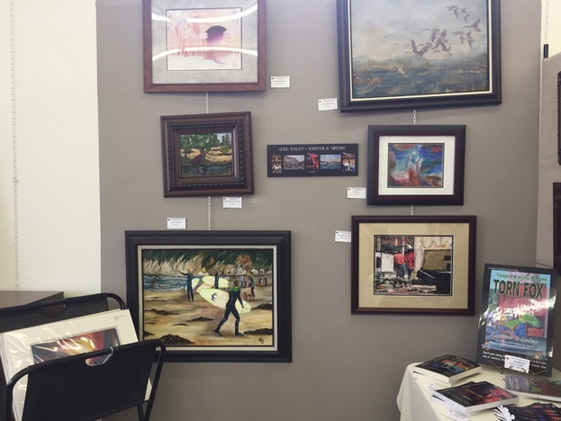
- ACA Showcase artist for July is Gail Daley"
- CAG Featured Artist at the July Meeting: Jackie McCoy
- Clovis Art Guild Picks of the Month for June

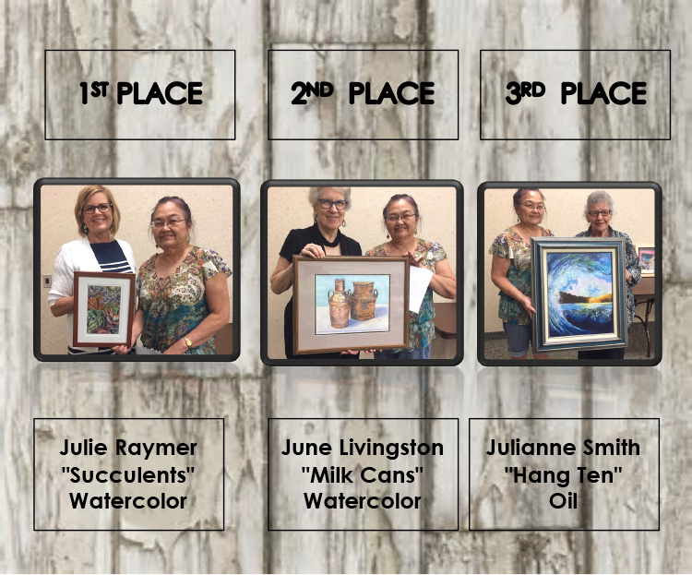

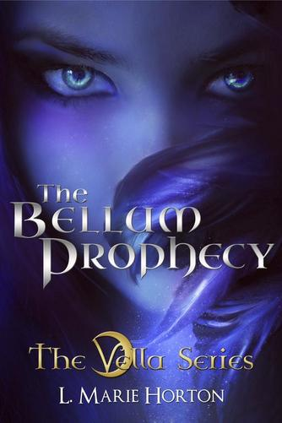
Lisa Horton is an attorney practicing law in Fresno, California. After completing her degrees, she gave the left side of her brain a rest and became devoted to writing fiction. Now she can’t imagine a day when she is not writing. Lisa is also a photographer, avid speed-reader, and an obsessive fan of movie soundtracks. She has a supportive husband and two fur children, Scottie a.k.a. Daba D and Gunnar a.k.a. da Gun Gun’s.
L. MARIE HORTON
L. Marie writes YA paranormal romance and fantasy fiction focusing on strong characters trying to overcome extraordinary obstacles in their life. Writing is an extreme passion of hers and she relishes in sharing that passion with her readers.
L. Marie Horton is thrilled to announce that Book One of the Vella Series, "The Bellum Prophecy" is now available in paperback for purchase at Amazon.com and the CreateSpace eStore.
Click here for the link to purchase the Kindle version.
Seventeen-year-old Edyn Vella always knew that her strange dreams of the future made her unique, but she never knew what they meant. However, when she fails to stop her aunt’s murder by an ominous vampiric creature, Edyn learns that her prophetic visions aren’t the only superhuman ability she possesses. Following her late aunt’s clues, Edyn finds herself in New York City attempting to save her last surviving relative, the powerful and reclusive billionaire, Ethan Roux. Edyn not only discovers Ethan isn't exactly human, but that she is at the center of an ancient prophecy and could determine the outcome of an impending war.
As Ethan’s Omega, his only human descendant, she’s thrust into an enigmatic world full of new supernatural creatures where both good and evil vampires and warlocks have waged a centuries-long battle for the fate of humanity. Just as her relationship with the mysterious and handsome Brendan begins to blossom, Edyn’s complicated new life quickly spirals out of control when ancient evil becomes determined on making her one of them. Edyn must discover her inner strength while making the choice between a long life without love and a potentially short life full of it.

http://www.lmariehortonauthor.com/

MARY MAUGHELLI
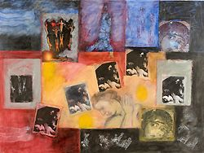
Mary Maughelli is a painter involved in using photo collage and has been an exhibiting and producing artist for more than 40 years. She has shown her work locally in Fresno as well as at AIR Gallery in New York for 14 years, the most recent being a 2007 exhibition titled Wish You Were Here VI.
Maughelli was invited by Judy Chicago, with whom she taught at Fresno State College (now California State University, Fresno), to show in the opening exhibition at Womanspace in Los Angeles. She also exhibited her work at the Woman's Building in Los Angeles in the 70's and late 80's. She has been a member of the Southern California Women's Caucus for Art for numerous years and was included in Curator's Choice, (2005) at The Brewery in Los Angeles and Female, Feminine, Feminist (2003) at the Orlando Gallery in Tarzana, CA.
Maughelli is a Professor Emerita of Art from California State University, Fresno where she taught for 35 years. She is also a Fulbright Fellowship recipient who was granted two years of painting in Florence, Italy after she completed her MA at the University of California, Berkeley in 1959.
In my work, I am concerned with being a woman, growing up female, and the female body. My work is about identity, young girls, the state of innocence, and woman.
These paintings are developed through interrelating, layering, and repetition of images from my drawings and from paintings in art history as well as other art forms such as earth works. Xeroxes, which are collaged and painted with oil bars, are used along with drawn transferred figures, objects, and symbols.
I have used images from Botticelli especially the Venus figure, Artemisia Gentileschi, particularly, Susanna from Susanna and the Elders, Gilbert and George, and most recently Robert Smithson's Spiral Jetty, to name a few. Through the juxtaposition of the figure from the past and present together with symbols, a more unique view of the body and women results which relies on personal associations rather than on outwardly descriptive imagery.

WEBSITES:
http://www.scwca.org/profile/mary-maughelli
http://www.airgallery.org/index.cfm?fuseaction=main.artists&artistid=870
See Mary's 3-part You Tube video interview here:
1) http://www.youtube.com/watch?v=WRThNheCe_M
2) http://www.youtube.com/watch?v=QOuxVYZfLAg
3) http://www.youtube.com/watch?v=HHwzUDbu6Bg

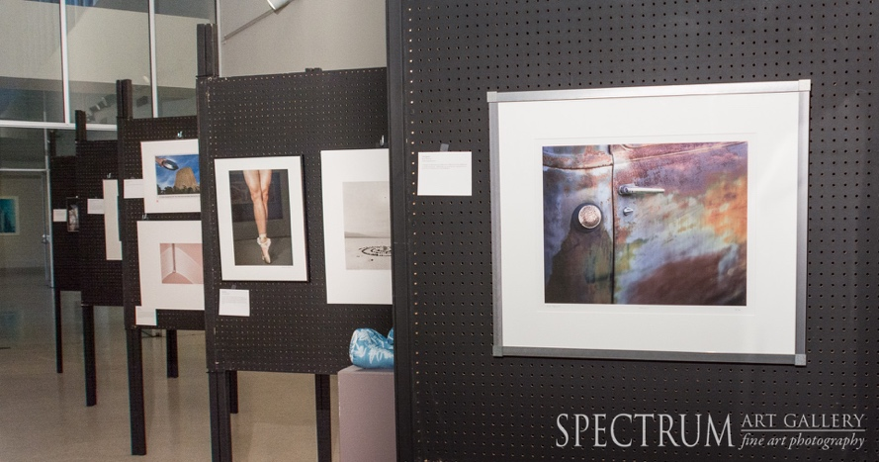
SPECTRUM ART GALLERY

Thirty years ago, exhibitions of photography as an art form appeared very infrequently, especially in the San Joaquin Valley. It was at that time a growing number of photographic artists began to congregate in a darkroom rental gallery establishment called Photosynthesis. By 1979 this group of local photographers formed a not-for-profit cooperative to create a local forum for the fine art of photography. In 1980, the group rented a space in Fresno's Tower District, and referring to the broad variety of work produced by the charter members called itself "Spectrum Gallery". This event is the primary annual fundraiser for Spectrum Gallery. Please join us to celebrate and support over 30 years of bringing fine art photography to the central valley. During the month of October, Spectrum will be exhibiting over 80 fine art photographs that will be auctioned off on October 26th. The exhibit will be at our gallery (608 East Olive Ave. Fresno, Ca.) and the auction itself will be at the Fresno Art Museum on Sunday evening, October 26th starting at 4:00 pm (for the reception – live auction starts at 5:00 pm).
Spectrum gallery is a cooperative organization that exhibits both local and out of area fine art photography. We are proud of giving our local artists an opportunity to exhibit their work in a premium gallery setting. We also bring in noted photographers each year to allow our local patrons to appreciate nationally recognized artists.
Our gallery is a 501c(3) registered non-profit organization.
LOCATION 608 E. Olive Ave. Fresno, Ca. 93728
phone (559) 266.0691 http://spectrumphotogallery.org
GALLERY HOURS
Thursday 12:30pm-5:00pm
Friday 12:30pm-8:00pm
Saturday 11:00am-5:00pm
Sunday 11:00am-5:00pm

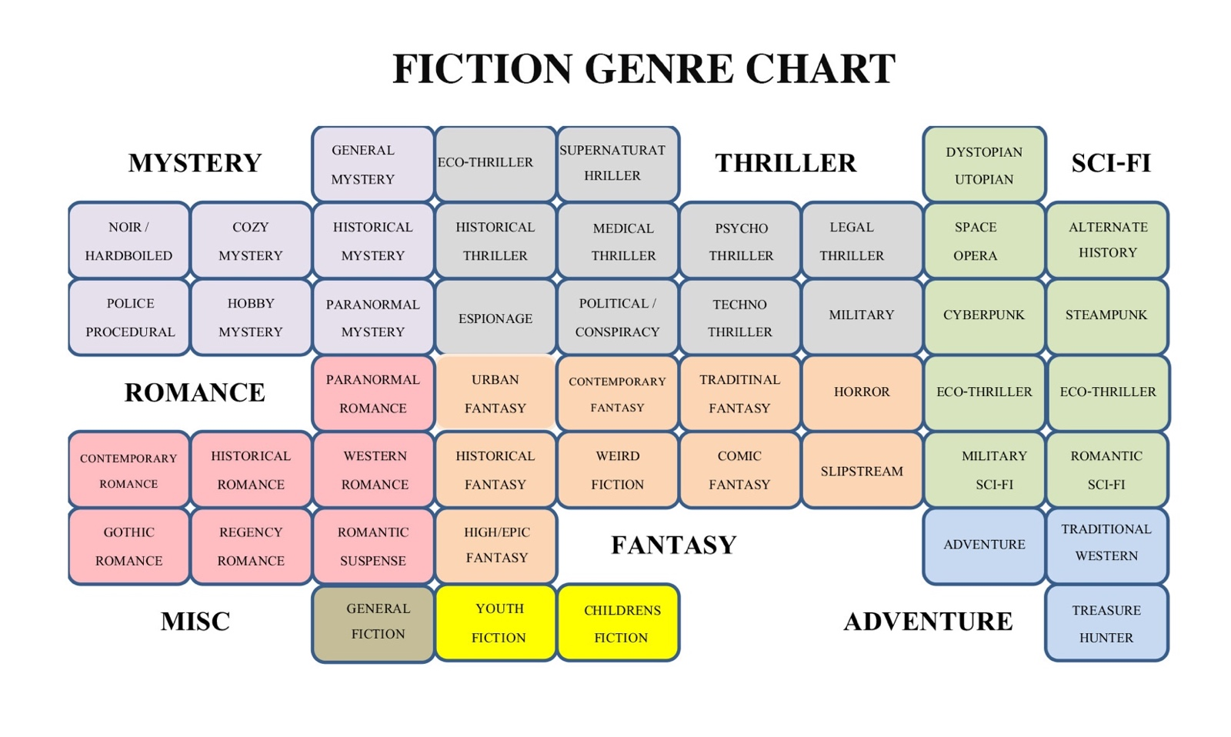
Several Years ago, I wrote a blog defining the many Art Genres. I decided to try the same with writing. I searched the internet and pulled up most of these definitions from Wikipedia, and various other internet sources who defined writing genre. It is by no means a comprehensive list, but it might help my fellow writers when asked by a publisher to define the genre of the book they have just written. There is an enormous amount of information about book genres. I limited myself to fiction. I may do a similar chart for non-fiction later though. I got the idea for the chart from a Facebook post, but I made some changes and additions to what was there. Please feel free to share or add to it.
WHAT DEFINES SCIENCE FICTION?
BLOG: THE PRACTICAL ARTIST
Science fiction or speculative fiction (often shortened to SF, sci-fi or scifi) is a genre dealing with futuristic science, technology, space travel, time travel, faster than light travel, parallel universes, and extraterrestrial life. Science fiction often explores the potential outcomes of scientific innovations, and has been referred a "literature of ideas," or future-casting. It usually avoids the supernatural, and unlike the related genre of fantasy, science fiction stories generally deal in plots and stories grounded in by some form of widely accepted scientific fact. Star Trek is based on the premise that man will discover a way to conquer light speed, or access parallel dimensions.
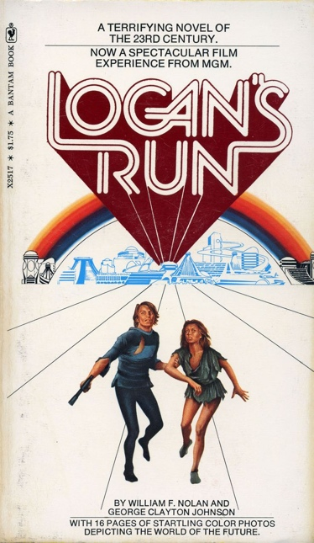
Dystopian / Utopian: utopia and its derivative, dystopia, are genres exploring social and political structures. Utopian fiction shows a setting agreeing with the author's ideology, and has attributes of different reality to appeal to readers. Dystopian (or dystopic) fiction (sometimes combined with, but distinct from apocalyptic literature) is the opposite. It shows a setting that completely disagrees with the author's ideology. Many novels combine both, often as a metaphor for the different directions humanity can take, depending on its choices. Both utopias and dystopias are commonly found in science fiction and other speculative fiction genres and arguably are a type of speculative fiction.
Dystopian
Apocalyptic Science Fiction is a sub-genre of Dystopian Science Fiction covering the end of civilization, through nuclear war, plague, or some other general disaster. The time frame may be immediately after the catastrophe, focusing on the travails or psychology of survivors, or considerably later, often including the theme that the existence of pre-catastrophe civilization has been forgotten or mythologized. Post apocalyptic stories often take place in an agrarian, non-technological future world, or a world where only scattered elements of technology remain.
Space Opera: is a subgenre of science fiction emphasizing space warfare, melodramatic adventure, interplanetary battles, risk-taking, and chivalric romance. Set mainly or entirely in outer space, it frequently involves conflict between opponents possessing advanced abilities, futuristic weapons, and other sophisticated technology. The term has no relation to music but was coined during the 1930s to indicate clichéd and overused stories in several genres. Space operas emerged in the 1930s and they continue to be produced in literature, film, comics, and video games. The most notable was probably produced by E.E. "Doc" Smith in the 1930's.
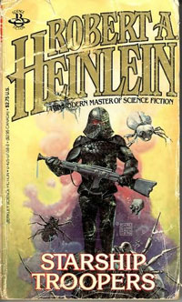
Cyberpunk: Cyberpunk is a subgenre of science fiction taking place in a future setting. It tends to focus on society as "high tech low life" showcasing advanced technological and scientific accomplishments, such as information technology and cybernetics, creating a breakdown or radical change in the social order. Cyberpunk plots often center on conflict among artificial intelligences, hackers, and megacorporation's in a near-future Earth. The settings are usually post-industrial dystopias but feature extraordinary cultural turmoil and the use of technology in ways never anticipated by its original inventors. Much of the genre's atmosphere echoes film noir writers and often uses modus operandi from this genre of detective fiction.
Military
Military Science Fiction: is a subgenre of science fiction that uses science fiction technology, mainly weapons, for military purposes. Its principal characters are generally members of a military organization involved in military activity. The action sometimes takes place in outer space or on a different planet or planets. It is found in literature, comics, film, and video games. A detailed description of the conflict, the tactics and weapons used, and the role of a military service and the individual members of that military organization generally forms the basis for a work of military science fiction. The stories often use events of actual past or current Earth conflicts, with countries being replaced by planets or galaxies of similar characteristics, battleships replaced by space battleships and certain events changed so that the author can induce what might have occurred differently.
Hard/Soft Science Fiction: is a category of science fiction marked by an emphasis on scientific accuracy. The terms were first used in print in 1957 by P. Schuyler Miller in a review of John W. Campbell, Jr.'s "Islands of Space" in Astounding Science Fiction. The complementary term Soft Science Fiction, formed by comparison to hard science fiction, first appeared in the late 1970s. It was created to emphasize the distinction between the "hard" (natural) and "soft" (social) sciences. Science fiction critic Gary Westfahl thinks that both terms are just ways of describing stories that reviewers and commentators have found useful.
Alternate History: or alternative history (British English), sometimes abbreviated as AH, is a genre of stories in which one or more historical events occur differently than as history recorded them. These stories are set in a world in which history has deviated from history as it is generally known; more simply put, alternate history asks the question, "What if history had developed differently?" Most works in this genre are set in real historical contexts, yet feature social, geopolitical or industrial settings that developed differently or at a different pace from our own. This subgenre comprises fiction in which a change or point of divergence happens that causes history to diverge from our own.
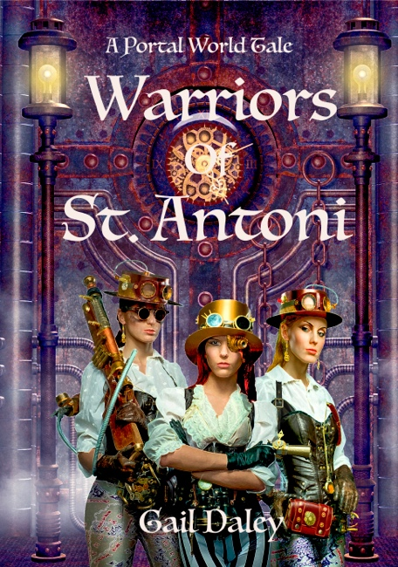
Steampunk: is a subgenre of science fiction or science fantasy that refers to works set in an era where steam power is still widely used;19th century's British Victorian era or American "Wild West, where steam power has maintained mainstream usage, or in a fantasy world that employs steam power in the same way. Although its literary origins are sometimes identified with the cyberpunk genre, it has marked differences. Inventions like those found in the works of H. G. Wells and Jules Verne are often included. Steampunk encompasses alternate history-style elements of past technology like dirigibles or mechanical computers combined with futuristic technology like multi-function goggles, giant robots and ray guns. Steampunk may be described as neo-Victorian. It most recognizably features anachronistic technologies or retro futuristic inventions as people in the 19th century might have envisioned them, and is likewise rooted in the era's perspective on fashion, culture, architectural style, and art.
Cross Genre
Steampunk/Romantic Sci-Fi
Romantic Science Fiction: This genre seems to be written almost exclusively for and by women. In most cases, it is simply a love story set in the future or a distant planet, although it can be set in the past or an alternate world as well. It centers more on relationships than on science, and any futuristic or fantasy elements take second place to the relationships. Usually there is no attempt to explain why or how the technology works; only its actions are described. A flying car or spaceship is simply said to go places, time travel simply happens without any attempt to describe the scientific method by which this might work. Probably the two most recognizable writers of romantic science fiction are Jayne Castle's (AKA Krenz) books on Harmony and Diana Gabaldon's Highlander series (now a TV series). Romantic Sci-Fi includes the sub-genre of Romantic Fantasy (virtually the same except magic is used rather than technology). A fuller description of this sub genre can be found in the Romance category.
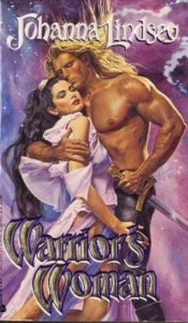
Romantic Science Fiction
Space Opera

The Local Art Events Newsletter is a free, on-line monthly publication for assisting artists and writers of California’s Central Valley and Central Coast to find places to show/sell their work, make connections with the local peer groups, and find classes, workshops, and tools that help them develop artistic and writing skills and the business side of their work. Printed copies are usually available at the general Meetings of ACA, CAG, and Allards Art supply in Fresno. It is distributed on-line.
ABOUT THE NEWSLETTER
The Newsletter welcomes notices and ads that agree with our stated purposes. All requests must include date, time, address and contact phone number or e-mail. If you wish to post an item to the calendar, it must be submitted by the 25th of the month prior to the event. All notices sent to members are subject to approval and editing, and no member information is ever given to 3rd parties. While every effort is made to ensure that the information on the calendar is accurate, most of the information is furnished from 3rd parties and The Newsletter is not responsible for changes made by those parties to the information furnished.

Editor: Gail Daley — Mailing Address: 5688 E Sussex Way, Fresno, CA 93727
localartevents@art-tique.org Visit us on the web: www.art-tique.org
YES! I want to subscribe to the newsletter
RETURN THIS COMPLETED FORM TO
Local Art Events
5688 E Sussex Way
Fresno, CA 93727
Please attach a copy Of Your
Biography And A Jpeg Photo Of Your Work For The Profile Section.
Name
Address
Phone Number
E-mail
Art Media OR
Writing Genre

POSTAGE
Local Art Events
5688 E Sussex Way
Fresno, CA 93727

